Histology – Epithelial Tissue

Name(s): ________________________

Period: _________ Date: ___________
HASPI Medical Anatomy & Physiology 04a
Activity

Background
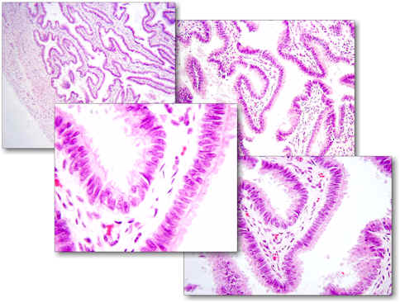
“Histology is an exotic meal, but can be as
repulsive as a dose of medicine for students who
are obliged to study it, and little loved by doctors
who have finished their study of it all too hastily.
Taken compulsorily in large doses it is impossible
to digest, but after repeated tastings in small
draughts it becomes completely agreeable and even
addictive.”
Quoted by Pio del Rio Hortega, 1933
Histology
Histology is the study of different types of tissues. In the medical field, cells and tissues from organs throughout the body can be collected through a biopsy and prepared for microscopic observation. Abnormal cells and tissues can then be compared to normal tissues to identify diseases, such as cancer. For this reason, a solid understanding of histology is crucial for healthcare professionals. Being able to know and recognize normal tissues under the microscope is the first step.

A few important tips when studying histology:
http://instruction.cvhs.okstate.edu/histology/fr/images/UterineHistologyThumbnail.jpg
PRACTICE | Number One…look at as many different histology slides as possible. The more practice, the better you will get. There are thousands of images, virtual labs, and practice quizzes online.
DON’T MEMORIZE | Understanding histology is NOT ABOUT MEMORIZATION! Even tissues from the same organ will look vastly different. It is all about noticing the patterns!
RECOGNIZE PATTERNS | Those who are good at recognizing histology work to recognize patterns. Most slides will have multiple tissue types. Don’t get lost in the big picture. Start by looking at individual cells, and patterns in how the cells are arranged.
FORM = FUNCTION | Keep in mind the FUNCTION of the tissue, and in the bigger picture, the function of the organ.
ONLY A PART OF THE PICTURE | REMEMBER the tissue on a slide or image is only a SECTION of that tissue. Slides from the same tissue can look VERY different depending on what part of the tissue it was taken from, the direction it was cut, and the type of stain used. For example, the images in Figure 1 are all from the stomach. As you can see, they all look vastly different!

Figure 1. The Stomach
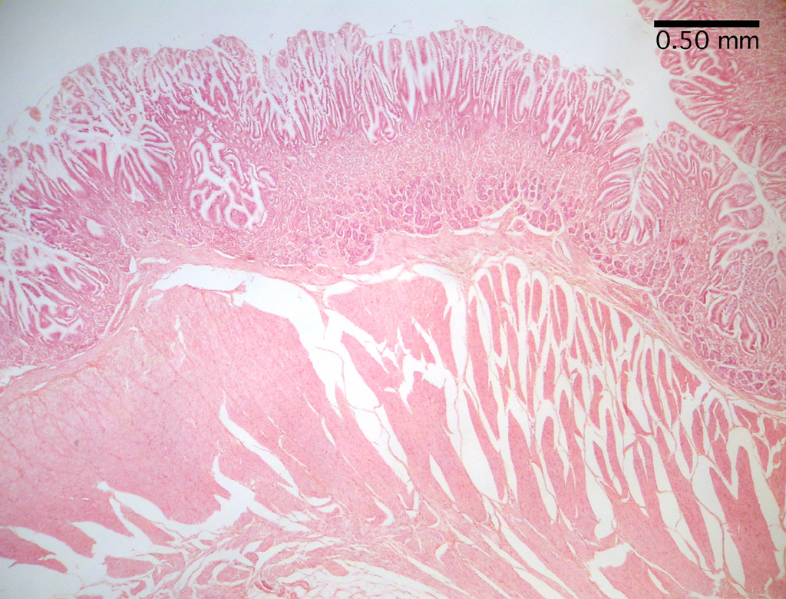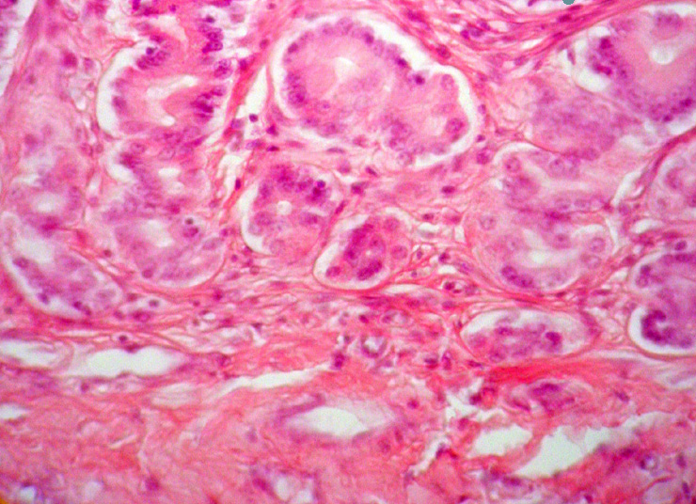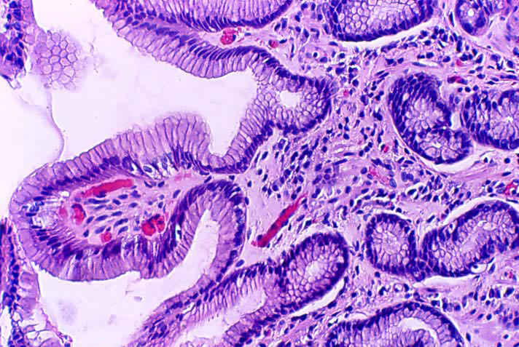

http://histology-world.com/photoalbum/thumbnails.php?album=26

Tissue Types
There are many different types of tissues in the human body, and they are separated into four major categories based on their function and the embryonic tissue of origin (developed in the womb). There are a few exceptions, but in general all four of these tissue types can be found in every organ.
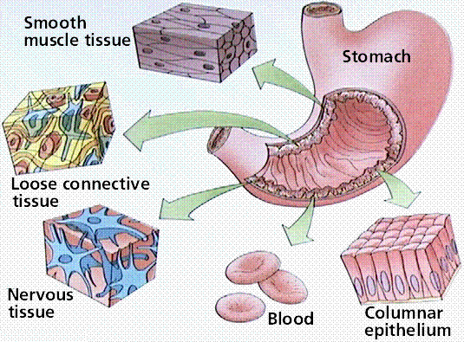
Tissue | Function | Embryonic Tissue
Epithelial | Cover & protection | Develops from the ectoderm, endoderm, and mesoderm
Connective | Support | Develops from the mesoderm
Muscle | Movement & contraction | Develops from the mesoderm
Nervous | Signaling & communication | Develops from the ectoderm
https://resources.oncourse.iu.edu/access/content/group/FA09-KO-OTHR-PRAC-18273/Helpful%20Websites/histology1.gif
Epithelial Tissue
Epithelial tissue can be found lining nearly every cavity and surface of the human body. Epithelium
can also form pockets and function as glands. Cells in epithelial tissue pack tightly together to form a
protective layer around organs. Many epithelial cells also produce fluids necessary for lubricating tissues and organs within the body. Epithelium tissue rests on a layer of cells called a basement membrane. The basement membrane is important as many epithelial tissues are avascular, meaning there are no capillaries that directly nourish the cells in epithelium tissue. Instead these cells get what they need through diffusion of nutrients through the basement membrane.

Epithelial tissues function to:
- Protect the tissues they cover
- Regulate gas and nutrient exchange between the organs they cover and body cavities
- Secrete substances such as sweat, hormones, mucus, and enzymes
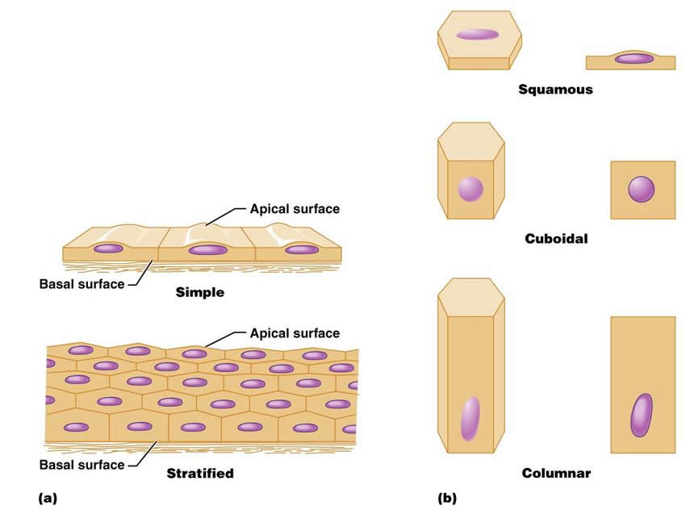
- Provide sensation with the environment

Epithelial Tissue Classification
Figure 2. Epithelium Tissue
Epithelial tissues are classified by the arrangement of
cells. The actual cell shape can be squamous (flat),
cuboidal (cube-shaped), or columnar (column-shaped)
as shown in Figure 2. In addition, the tissue can be
simple and made up of a single layer of cells, or
stratified and made up of more than one layer of cells.
Epithelial tissue can also be transitional or
pseudostratified. A transitional epithelium tissue is
“transitioning” from the shape of one cell to another.
For example, it could be moving from squamous to
http://classes.midlandstech.edu/carterp/Courses/bio210/chap04/chap04.html
columnar. Pseudostratified epithelium is only a single
layer of cells, but the location of the nuclei of those cells makes it appear stratified.

In addition to these classification guidelines, there are other structural differences that can be used to identify epithelial tissues. Some epithelial tissue is ciliated and capable of interacting with the external environment. For example, ciliated epithelial tissue lining the trachea catches foreign particles and moves them away from the lungs. Epithelium tissue may also have a layer that is no longer receiving nutrients, and is therefore dead. It forms layers of dead tissue that provide more protection, and is most commonly seen on the outside of the skin. This is called keratinized epithelium tissue.

Materials
Epithelial tissue charts (8)
Computer/Internet OR Epithelium slides and a microscope
Directions
Figure 3. Salivary glands
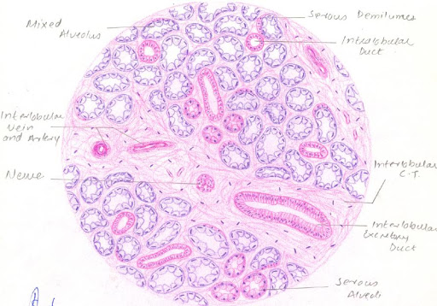
Part A. Becoming Familiar with Epithelial Tissues
In Part A of this lab you will have the opportunity to
familiarize yourself with the different types of
epithelial tissues. Posters with the 8 main types
of tissues have been placed throughout the room.
Visit each poster and record the description, function,
and location in the following chart. Draw and label an
example in the space to the right for each picture.
An example drawing can be seen in Figure 3 to
the right.

http://lh3.ggpht.com/-3sbwwA-QEnQ/Rrey7AXDWnI/AAAAAAAAARk/Pk6AdPAx2N8/Sublingual%252520Gland.JPG
a. Simple Squamous Epithelium
Description (write or draw) | Draw an example. Use colored pencils and label if necessary.
Function

Location

b. Simple Cuboidal Epithelium
Description (write or draw) | Draw an example. Use colored pencils and label if necessary.
Function

Location

c. Simple Columnar Epithelium
Description (write or draw) | Draw an example. Use colored pencils and label if necessary.
Function

Location

d. Pseudostratified Columnar Epithelium
Description (write or draw) | Draw an example. Use colored pencils and label if necessary.
Function

Location

e. Stratified Squamous Epithelium
Description (write or draw) | Draw an example. Use colored pencils and label if necessary.
Function

Location

f. Transitional Epithelium
Description (write or draw) | Draw an example. Use colored pencils and label if necessary.
Function

Location

g. Stratified Cuboidal Epithelium
Description (write or draw) | Draw an example. Use colored pencils and label if necessary.
Function

Location

h. Stratified Columnar Epithelium
Description (write or draw) | Draw an example. Use colored pencils and label if necessary.
Function

Location

Part B. Identify the Epithelial Tissue
In Part B of this activity, use what you have just learned to identify the following epithelial tissues.
Is the tissue squamous, cuboidal, columnar, or transitional? Is the tissue simple, stratified, or pseudostratified? Write your answers on the line in each box.
A. ___________________  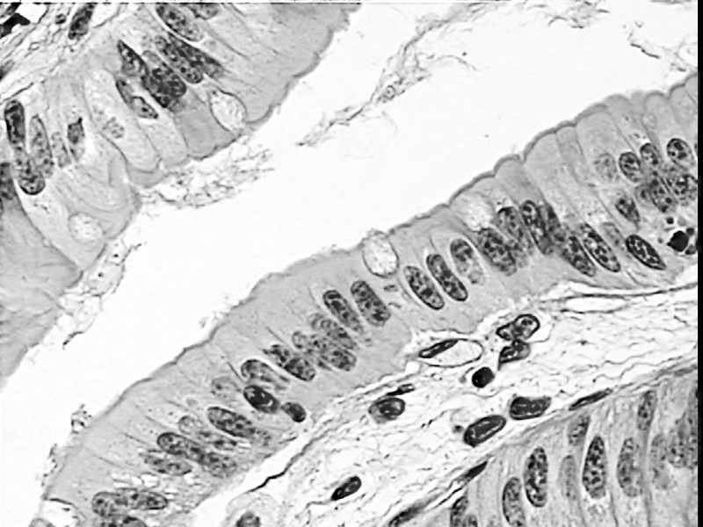 | B.____________________  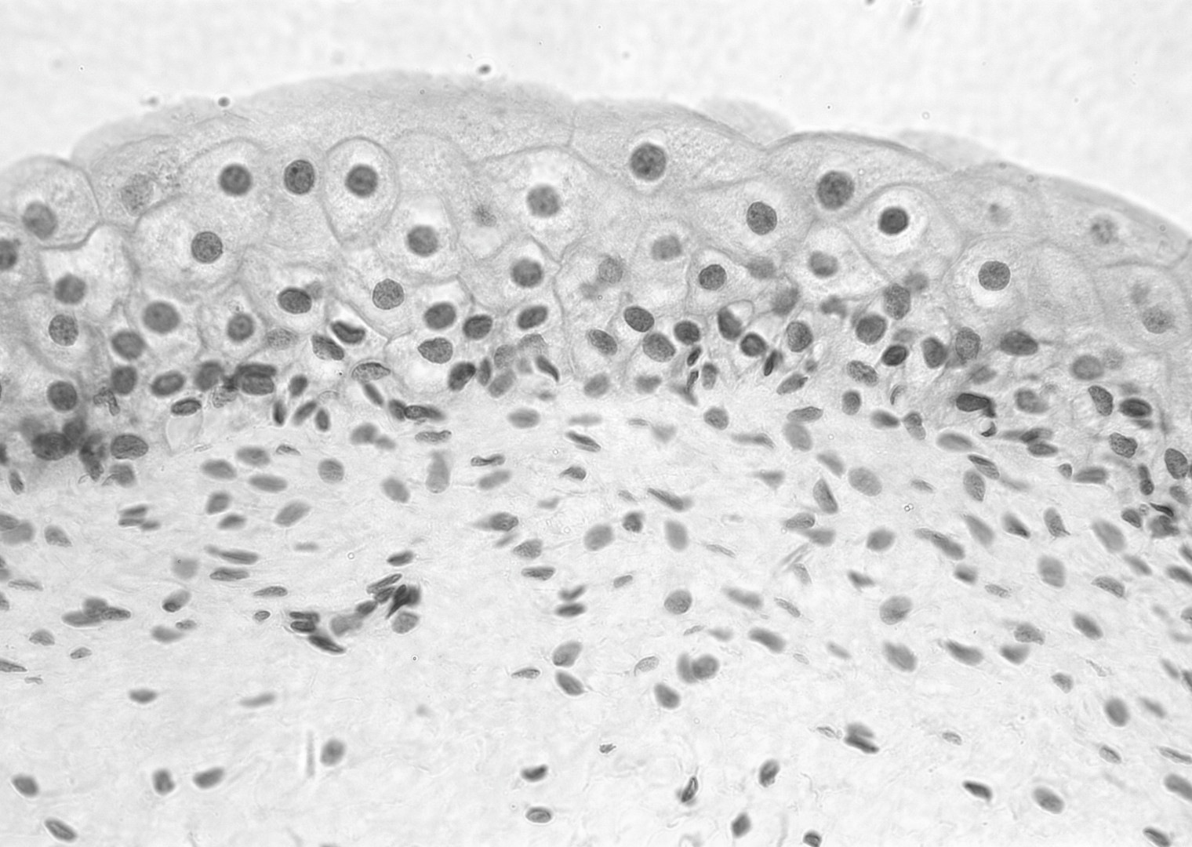 | C. ____________________ 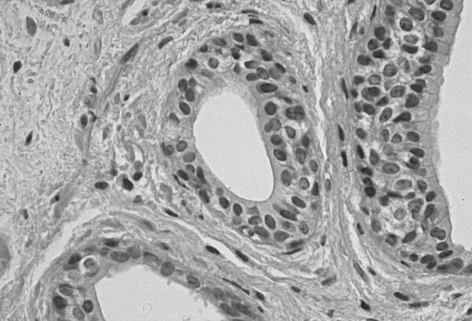
D. ___________________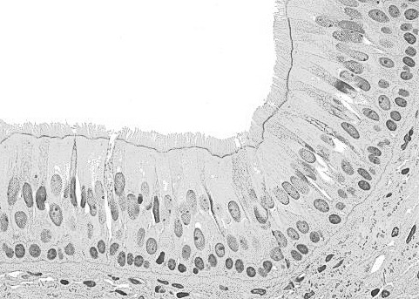 | E. ___________________  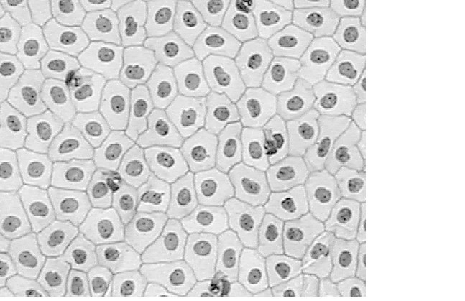 | F. ____________________  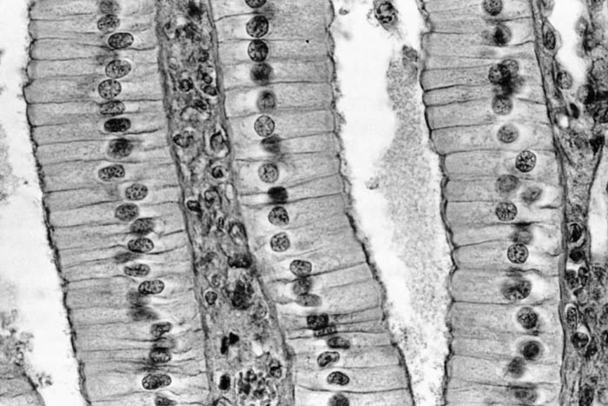
G. ___________________  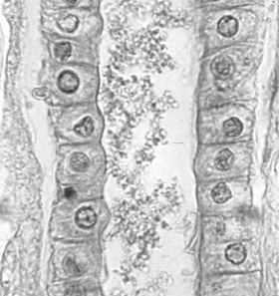 | H. ___________________  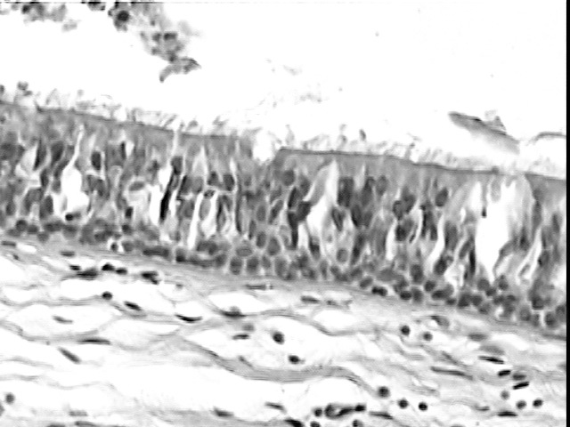 | I. _____________________  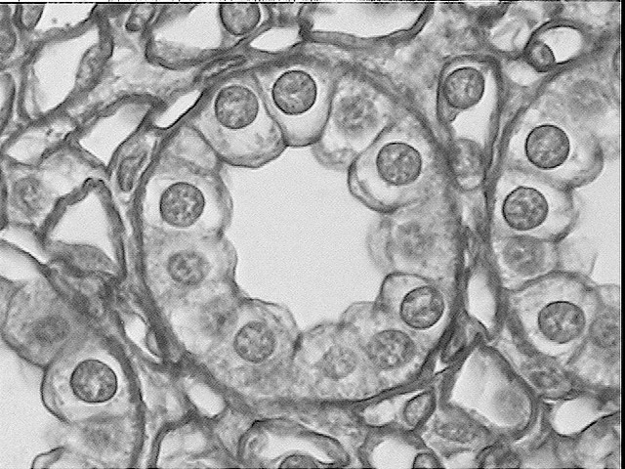
J. ____________________  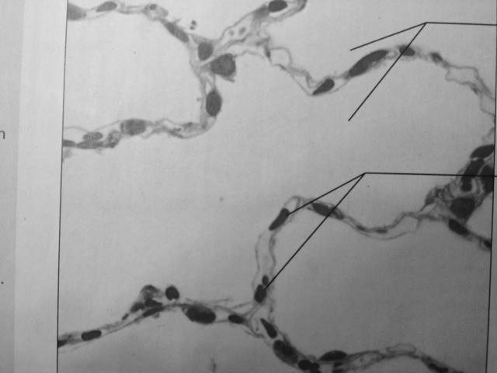 | K. ___________________ 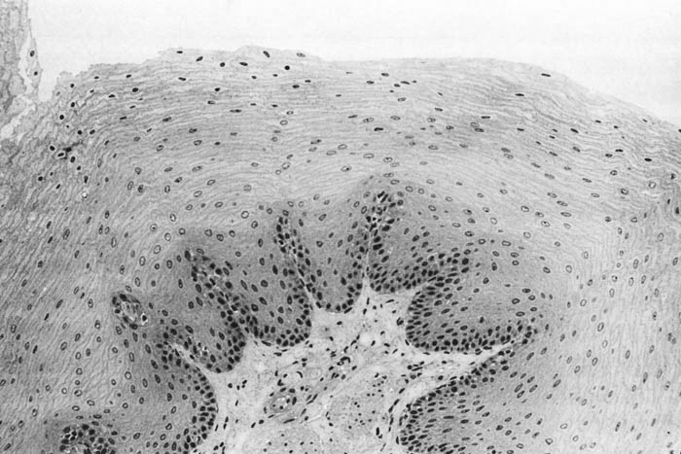 | L. ____________________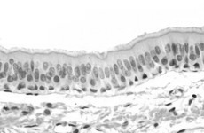

A. http://science.tjc.edu/Course/BIOLOGY/1409/simple_columnar_ep.jpg
B. http://sciweb.hfcc.edu/Biology/AP/134/lab/lab%20guide%20images/Histology/Bio%20134%20photomicrographs.400x/Trans%20E%20400x.3.jpg
C. http://www.pathguy.com/histo/081.jpg
D. http://stevegallik.org/sites/histologyolm.stevegallik.org/images/PseudoCilia4.jpg
E. http://science.tjc.edu/Course/BIOLOGY/1409/squamouslow.jpg
F. http://im.glogster.com/media/4/21/13/65/21136509.jpg
G. http://bio.rutgers.edu/~gb102/lab_6/epithelium/cuboidal_high_kc.jpg
H. http://science.tjc.edu/Course/BIOLOGY/1409/ciliatedpseudostrat.jpg
I. http://science.tjc.edu/Course/BIOLOGY/1409/cuboidal2.6-9.jpg
J. http://classconnection.s3.amazonaws.com/112/flashcards/844112/jpg/simple_squamous_epithelium1336529145515.jpg
K. http://www.stegen.k12.mo.us/tchrpges/sghs/ksulkowski/images/13_Stratified_Squamous_Epithelial_Tissuetemp_000.jpg
L. http://o.quizlet.com/i/_F3HzOtZs1wgdIybe41sXQ_m.jpg
Part C. Practice, Practice, Practice
Your instructor will either have slides available to view with the microscope OR you can use a computer and the following website to choose slides to view:

http://medsci.indiana.edu/c602web/602/c602web/virtual_nrml/nrml_lst.htm

For each type of epithelial tissue, choose a listed organ and find that type of epithelial tissue on that organ slide.
- REMEMBER there are multiple tissue types on many of the slides.
- Start by searching at the edges of the slide sample for the epithelial tissues, and focus at the cell level.
- You may need to move the slide around to find a good example!
- You may need to look up/research the organ function if it is unfamiliar.

a. Simple Squamous Epithelium
Organ Choices: Lungs (alveoli), lymph vessels, lining of blood vessels (arteries, capillaries, and veins), pericardium, peritoneum, Bowman’s capsule (kidneys), pleural cavity lining
Organ | Draw an example. Use colored pencils.
Organ Function

Tissue Function

b. Simple Cuboidal Epithelium
Organ Choices: Thyroid, pancreas, ovaries, testes, bronchioles, kidney tubules
Organ | Draw an example. Use colored pencils.
Organ Function

Tissue Function

c. Simple Columnar Epithelium
Organ Choices: Stomach, small intestine, large intestine, rectum, gallbladder, fallopian tubes, endometrium, cervix, bulbourethral gland, uterus
Organ | Draw an example. Use colored pencils.
Organ Function

Tissue Function

d. Pseudostratified Columnar Epithelium
Organ Choices: Epididymis, vas deferens, urethra, seminal vesicle, larynx, trachea, nose
Organ | Draw an example. Use colored pencils.
Organ Function

Tissue Function

e. Stratified Squamous Epithelium
Organ Choices: Gums, tongue, hard palate, esophagus, anus, skin, cervix, vagina, labia, pharynx, larynx, cornea
Organ | Draw an example. Use colored pencils.
Organ Function

Tissue Function

f. Transitional Epithelium
Organ Choices: Renal pelvis, ureter, bladder, urethra
Organ | Draw an example. Use colored pencils.
Organ Function

Tissue Function

g. Stratified Cuboidal Epithelium
Organ Choices: Sweat glands
Organ | Draw an example. Use colored pencils.
Organ Function

Tissue Function

h. Stratified Columnar Epithelium
Organ Choices: Submandibular glands, conjunctiva, pharynx, anus, uterus, urethra, vas deferens
Organ | Draw an example. Use colored pencils.
Organ Function

Tissue Function

Analysis Questions - on a separate sheet of paper complete the following
- Create a concept map titled “Epithelial Tissues” with a
short description OR a drawn example including ALL of
the following: simple squamous, simple cuboidal,
simple columnar, transitional, stratified squamous,
stratified cuboidal, stratified columnar, and
pseudostratified.
- What is the difference between simple squamous,
simple cuboidal, and simple columnar epithelial tissues?
- What is the difference between stratified squamous,
stratified cuboidal, and stratified columnar epithelial
tissues?
- What is the difference between transitional and
pseudostratified epithelial tissues?
- What type(s) of epithelial tissue can be found in the stomach?
- What type(s) of epithelial tissue can be found in the lungs?
- What type(s) of epithelial tissue can be found on the surface of the skin?
- What type(s) of epithelial tissue can be found in the bladder?
- What type(s) of epithelial tissue can be found in the sweat glands?
- Identify the type of epithelial tissue for A-E in Figure 4
to the right.
- CONCLUSION: In 1-2 paragraphs summarize the procedure and results of this lab.

Figure 4
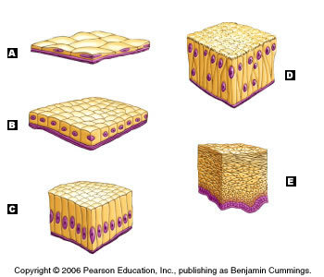

http://wps.aw.com/wps/media/tmp/labeling/2807010_dyn.jpg

Review Questions - on a separate sheet of paper complete the following
- What is histology?
- Why is histology important to medicine?
- Why is it important to have a good understanding of normal histology before examining abnormal histology?
- List the 5 important tips to remember when studying histology.
- What are the four major categories of tissues in the human body?
- How are the four categories of tissues separated or what are they based upon?
- Where can epithelial tissue be found in the human body?
- What is the purpose of the basement membrane?
- What are the four main functions of epithelial tissues?
- What is the difference between squamous, cuboidal, and columnar epithelial cells?
- What is the difference between simple and stratified epithelial tissues?
- What is transitional epithelium?
- What is pseudostratified epithelium?
- What is the function of ciliated epithelial tissue?
- What is the function of keratinized epithelial tissue?

